# Question 1:

## Multiple Scatter SAS:

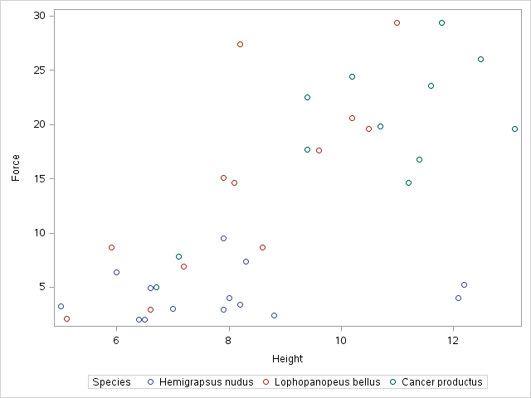

Regression Eq:

{F:Height|Cancer} β0+β1⋅Can+β2⋅Hemi+β3⋅Height+β4⋅Can⋅Height+β5⋅Hemi⋅Height

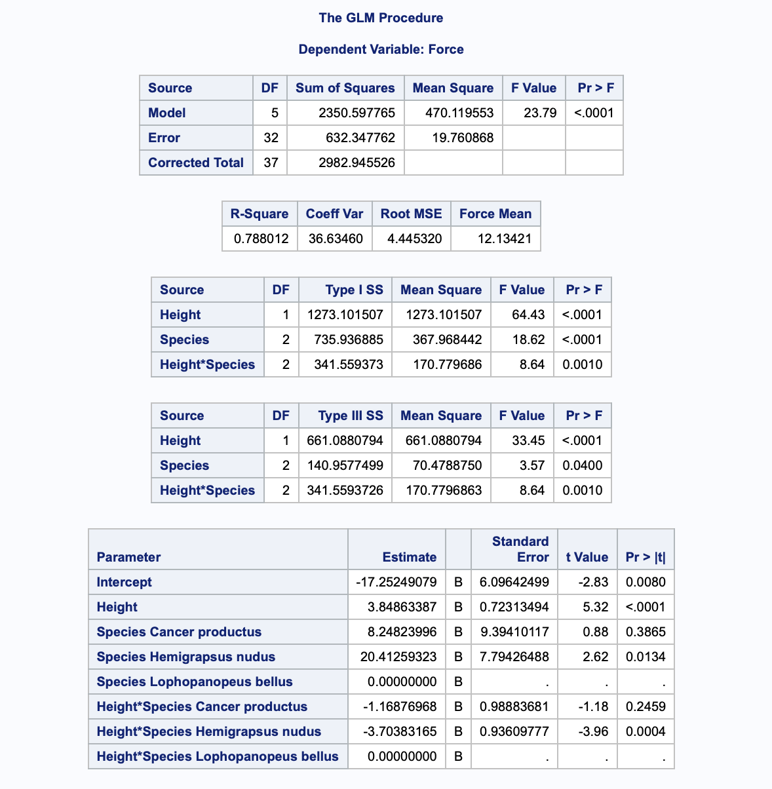

F=-17.25+8.25⋅Can+20.41⋅Hemi+3.85⋅Height-1.17⋅Can⋅Height-3.70⋅Hemi⋅Height

Cancer_p and lophophan slopes are not statistically significant from zero

## Interpret Plots:

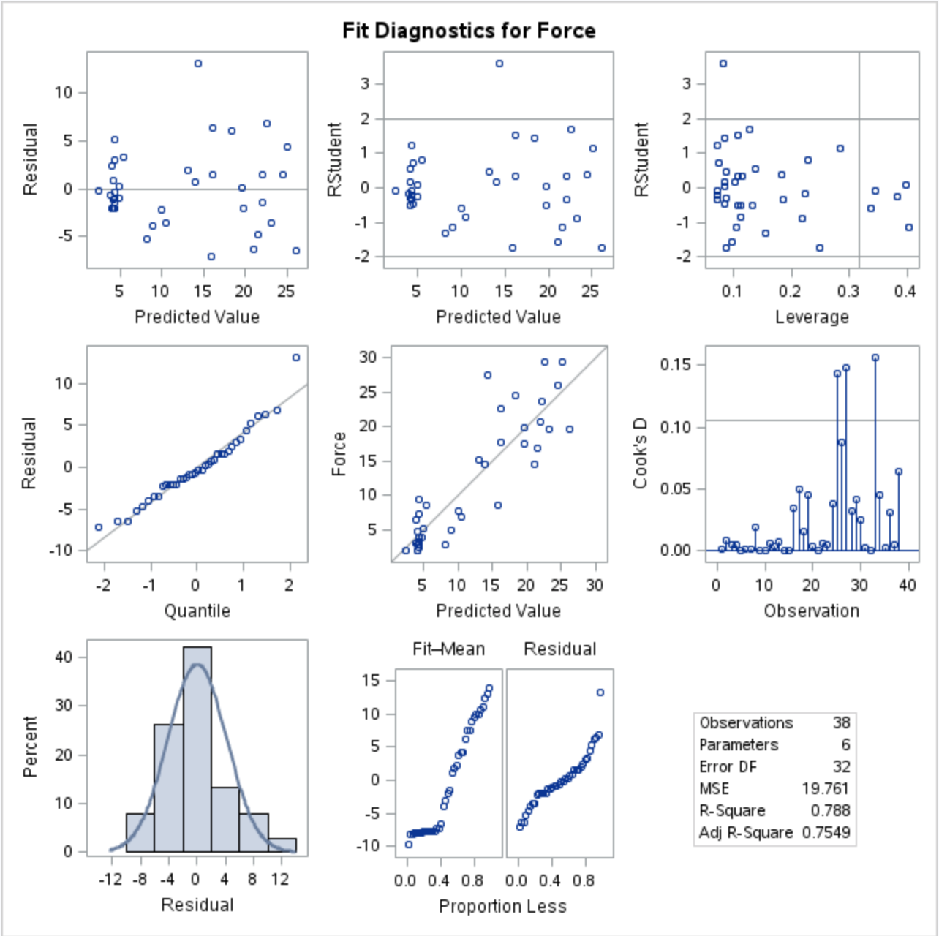

**Histogram of Residuals: The histogram of residuals appears normal.**

**Q-Q Plot of Residuals: also appears normal**

**Residual Plot: slightly bunched at the lower end of the range**

**Stud Residual Plot: Observation 15 looks suspect**

0: Estimated at -17.25, represents the force of the reference level crab with a height of zero.

Zero height crabs don’t exist. ☺

1: intercept adjustment for crab level 2 (cancer)

3: intercept adjustment for crab level 3 (hemi)

3: slope adjustment for reference crab

4: slope adjustment for crab level 2 (cancer)

5: intercept adjustment for crab level 3 (hemi)

Reference (all class vars = 0)

F=-17.25+3.85⋅Height

Cancer

F=-9.00+2.68⋅Height

Hemi

F=3.16+0.15⋅Height